**Database Structure Tables:**

1. NEU_Program:

1. NEU_Course_Catalog Table:

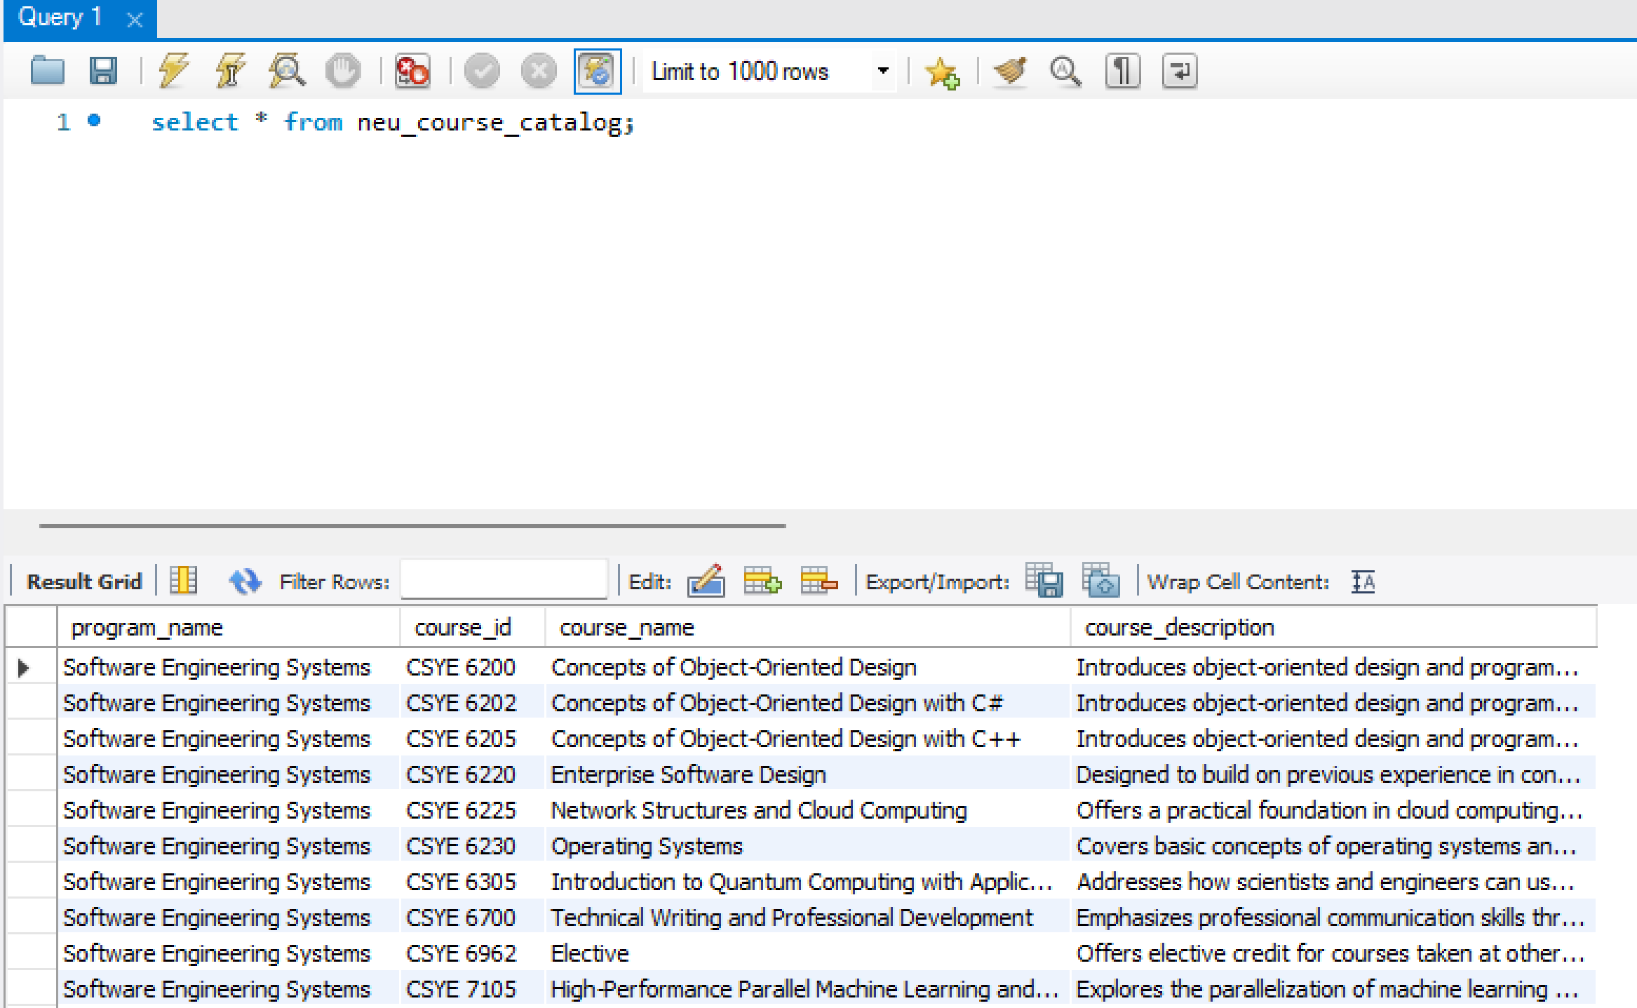

1. NEU_Event Table:

1. Course_Core_Requirement Table:

1. NEU_Course_Resource Table:

1. NEU_Resource_Materials Table:

1. Job_Info Table:

1. Program_Jobs Table:

1. NEU_Facultys Table:

1. NEU_Course_faculty Table:

1. NEU_Specialization Table:

1. NEU_Course_Specialization Table:

